EX. NO.: 25
TITLE
QR ENABLED AUTOMATIC BUS TICKET BOOKING SYSTEM
AIM
To create an automatic bus ticket booking system that generates a QR code containing the ticket information and makes the passenger's journey easier.

PROCEDURE
- Install the latest version of Python and MySQL.
- Check the Python and MySQL versions.
- Install the required Python modules.
- Create the required database and tables.
- Establish a connection between Python and MySQL.
- Import the required modules.
- Create functions for passenger registration, login, ticket cancellation, QR-code generation and ticket display.
- Assemble and call the required functions.
- Run the program and verify the output.
The source specifies Python, MySQL, Tkinter, qrcode, PIL, random and mysql-connector as the main software/modules.

PROGRAM
1. Import Required Modules
import tkinter as tk
from tkinter import messagebox
import mysql.connector
import random
import qrcode
from PIL import Image, ImageTk

2. Connect Python with MySQL
conn = mysql.connector.connect(
host="localhost",
user="root",
password="pugalytff",
database="MobileDB"
)

cursor = conn.cursor()

print("MySQL Connected Successfully")

3. Create Passenger Table
cursor.execute("""
CREATE TABLE IF NOT EXISTS passenger2
(
id INT AUTO_INCREMENT PRIMARY KEY,
first_name VARCHAR(255),
last_name VARCHAR(255),
password VARCHAR(255)
)
""")

conn.commit()

print("Passenger table created successfully")

4. Passenger Registration
def register_passenger():

first_name = first_name_entry.get()
last_name = last_name_entry.get()
password = password_entry.get()
confirm_password = confirm_password_entry.get()

if password != confirm_password:
messagebox.showerror(
"Error",
"Passwords do not match!"
)
return

sql = """
INSERT INTO passenger2
(first_name, last_name, password)
VALUES (%s, %s, %s)
"""

values = (
first_name,
last_name,
password
)

cursor.execute(sql, values)
conn.commit()

messagebox.showinfo(
"Success",
"Passenger registered successfully"
)

5. Login
def login():

first_name = first_name_entry.get()
last_name = last_name_entry.get()
password = password_entry.get()

sql = """
SELECT * FROM passenger2
WHERE first_name = %s
AND last_name = %s
AND password = %s
"""

cursor.execute(
sql,
(first_name, last_name, password)
)

result = cursor.fetchone()

if result:
messagebox.showinfo(
"Login",
"Login Successful"
)
perform_operations()
else:
messagebox.showerror(
"Login",
"Login Unsuccessful"
)
6. Display Available Operations
def perform_operations():

operation_window = tk.Toplevel()
operation_window.title("Available Operations")
operation_window.geometry("350x250")

tk.Label(
operation_window,
text="Available Operations",
font=("Arial", 16, "bold")
).pack(pady=20)

tk.Button(
operation_window,
text="Generate QR Code",
command=generate_qr_code
).pack(pady=10)

tk.Button(
operation_window,
text="Display Ticket",
command=display_ticket
).pack(pady=10)

tk.Button(
operation_window,
text="Cancel Ticket",
command=cancel_operation
).pack(pady=10)

7. Generate QR Code
def generate_qr_code():

first_name = first_name_entry.get()
last_name = last_name_entry.get()

data = (
"BUS TICKET\n"
"First Name: " + first_name + "\n"
"Last Name: " + last_name
)

qr = qrcode.make(data)

qr_path = "qr_code.png"
qr.save(qr_path)

messagebox.showinfo(
"Success",
"QR Code Generated Successfully"
)

image = Image.open(qr_path)
image.show()
8. Display Ticket
def display_ticket():

first_name = first_name_entry.get()
last_name = last_name_entry.get()

ticket = (
"===== BUS TICKET =====\n"
"First Name: " + first_name + "\n"
"Last Name: " + last_name + "\n"
"Status: BOOKED\n"
"======================"
)

messagebox.showinfo(
"Ticket",
ticket
)
9. Cancel Ticket
def cancel_operation():

first_name = first_name_entry.get()
password = password_entry.get()

sql = """
SELECT * FROM passenger2
WHERE first_name = %s
AND password = %s
"""

cursor.execute(
sql,
(first_name, password)
)

result = cursor.fetchone()

if result:

delete_query = """
DELETE FROM passenger2
WHERE first_name = %s
"""

cursor.execute(
delete_query,
(first_name,)
)

conn.commit()

messagebox.showinfo(
"Cancel",
"Operation Cancelled Successfully"
)

else:

messagebox.showerror(
"Cancel",
"Invalid Credentials"
)
10. Close MySQL Connection
cursor.close()
conn.close()

print("MySQL Connection Closed")

OUTPUTS
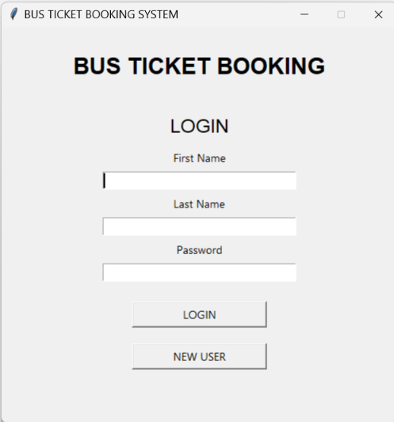
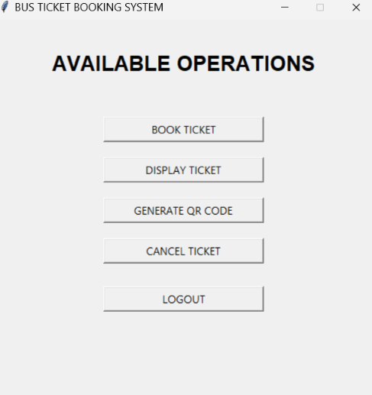
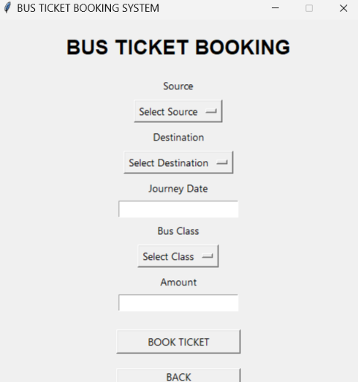
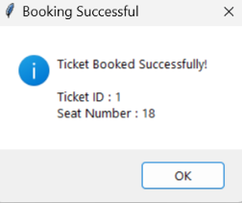
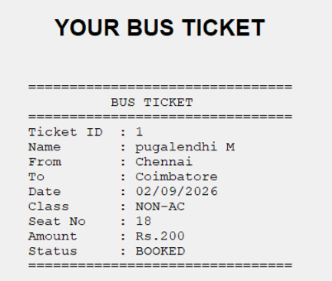


DATABASE
TABLE: PASSENGER2
USE MobileDB;

SELECT * FROM passenger2;
RESULT
Thus, the QR Enabled Automatic Bus Ticket Booking System was successfully implemented using Python and MySQL with passenger registration, login, ticket operations and QR-code generation.

